Education Performance Analysis
A Data Analytics Project Using R
Prepared by:
Makhema Rethabile Motsoetsoana

Tools Used:
- R
- Microsoft Excel
Techniques Applied

Project Overview
- This project analyses school performance data using R.
- Tools Used Excel (Data Collection & Cleaning) R (Statistical Analysis) Analysis
- Performed Summary statistics Correlation Analysis Data visualization
- Files Education.csv → dataset Schools.R → analysis code
- Objective of this to understand factors affecting school performance.

Analyses and the Interpretations
Below is the summary of the data:

Below is the table to tell the quantity of the school from which they are categorised as Rural or Urban.
Urban | Rural
44 | 55

Clearly, we can see that 56% of Schools are from Rural and 44% are from the Urban.

Data visualization of the results.
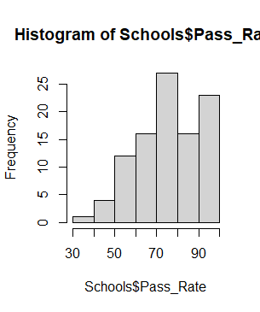

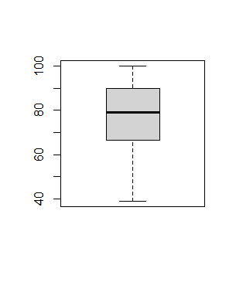
Figure1: Distribution of Pass rate Figure2: Spread of the pass rate

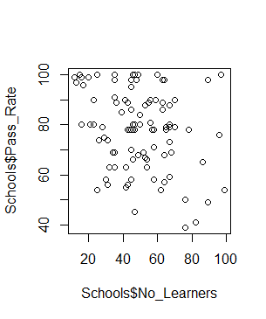

Figure3: Relationship between pass rate and the number of learners.

Correlation
The correlation between number of Learners and their pass rate is a negative correlation: -0.2660337, which means that it is very weak.

Summary of data in words
The dataset consists of 99 schools. The average number of learners per school is approximately 49, with a minimum of 12 and a maximum of 99 learners. This indicates variability in school sizes.
The average pass rate is 78.07%, with a median of 79%, suggesting that overall academic performance is relatively strong. However, the pass rate ranges from 39% to 100%, indicating disparities in performance across schools.

The effect of school size and the location on the academic performance
We go back to correlation again it is r=--0.2660337 which is the negative corelation. That simply tells us that as the number of learners increases, the pass rate decreases. However, since the relationship is weak the school size does not affect the performance.
According to the boxplot in Figure2 urban schools have a higher pass rate than the rural schools.
Statistical test to confirm the effect
Welch Two Sample t-test

data: Pass_Rate by Location
t = -0.39855, df = 88.853, p-value = 0.6912
alternative hypothesis: true difference in means between group Rural and group Urban is not equal to 0
95 percent confidence interval:
-7.808477 5.199386
sample estimates:
mean in group Rural mean in group Urban
77.49091 78.79545

Further analysis is required to determine whether factors such as school size and location influence academic performance.

